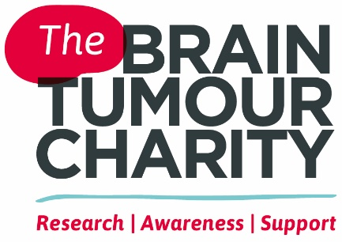
Gift Aid form
for multiple donations

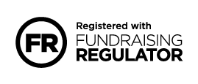
If you have held an event and asked people for voluntary donations,
or they have given a donation on top of an event ticket/entry price,
please ask them to complete their details below and return this form
to us when you send in the money you have raised.
Please include the donation only amount on this form so that we can
claim Gift Aid (which we can’t if you have charged for a ticket or goods).

Name

Address

Event

Supporter Group (if applicable)

  - Please Gift Aid your donation so we can claim Gift Aid tax relief of 25p on every pound you give
at no extra cost to you. Just tick the box on your sponsorship line and don’t forget to give your full home address and postcode.
By ticking the Gift Aid box, I confirm that I’m a UK tax payer and want to Gift Aid my donation and any other donations I have made in the past four years or make in the future to The Brain Tumour Charity. I’m aware that The Charity will reclaim 25p of tax on every £1 that I give and understand that I must pay more Income tax and/or Capital Gains Tax for that tax year than the amount of Gift Aid claimed on all my donations, I know it’s my responsibility to pay any difference. If my circumstances change, I will notify The Brain Tumour Charity.

Name  (please give your title, first name and surname) | Home address  (please give your home address or we can’t claim Gift Aid) | Postcode  (essential for Gift Aid) | Gift Aid?  ✓ | Amount paid
Ms Ann Sample | 1 Sample St, Sample Town | SM1 1SM | ☑ | £10.00
 |  |  |  | £
 |  |  |  | £
 |  |  |  | £
 |  |  |  | £
 |  |  |  | £
 |  |  |  | £
 |  |  |  | £
 |  |  |  | £
 |  |  |  | £
 |  |  |  | £
 |  |  |  | £
 |  |  |  | £
 |  |  |  | £
 |  |  |  | £
 |  |  |  | £
 |  |  |  | £

Gift Aid form
for multiple donations (continued)

Name  (please give your title, first name and surname) |  | Home address  (please give your home address or we can’t claim Gift Aid) | Postcode  (essential for Gift Aid) | Gift Aid?  ✓ | Amount paid
Ms Ann Sample |  | 1 Sample St, Sample Town | SM1 1SM | ☑ | £10.00
 |  |  |  |  | £
 |  |  |  |  | £
 |  |  |  |  | £
 |  |  |  |  | £
 |  |  |  |  | £
 |  |  |  |  | £
 |  |  |  |  | £
 |  |  |  |  | £
 |  |  |  |  | £
 |  |  |  |  | £
 |  |  |  |  | £
 |  |  |  |  | £
 |  |  |  |  | £
 |  |  |  |  | £
 |  |  | Subtotal (this page)
 |  |  | Subtotal (other pages)
 |  |  | GRAND TOTAL

How to get the money to us

Once you have finished your event/activity and collected all your donations you can:
- Go to the Donate section of our website, click on the Pay In Your Fundraising tab and pay using our secure website.
- Send a cheque for the full amount made payable to The Brain Tumour Charity to Hartshead House, 61-65 Victoria Road, Farnborough, GU14 7PA.
- Make an online transfer to our bank account: Lloyds Bank. Account No: 50290568. Sort Code: 30-93-74.
Please include REF: your name and your event so we know it’s from you and please email donations@thebraintumourcharity.org to let us know how much you’ve transferred to us.
- Give our team a call on 01252 237792 to request a paying in slip to pay the money into our bank account.
Please ensure that all donations collected offline (cash and cheques) are given to The Brain Tumour Charity in the form of one cheque or payment per participant.
Data Protection
We use the details you’ve provided to process your donation, including claiming any Gift Aid from HMRC. Your details, and those of your sponsors, are held on our secure database and we promise never to share them with any other organisation for their marketing purposes. You can read our full privacy policy on our website.
If you have any queries please get in touch: donations@thebraintumourcharity.org / 01252 237792

